<https://www.nesever.com.tr>

The project is a platform that allows you to buy gifts for your friends via social network.

.Net Core MVC, C#, MS Sql Server, Web Api, Entity Framework, Swagger, Serilog, Redis cache technologies were used in the project.

**Frontend user pages**

Mainpage (contains gift/product search, friend/people/user search, product categories, brand search, trend products, blog categories)

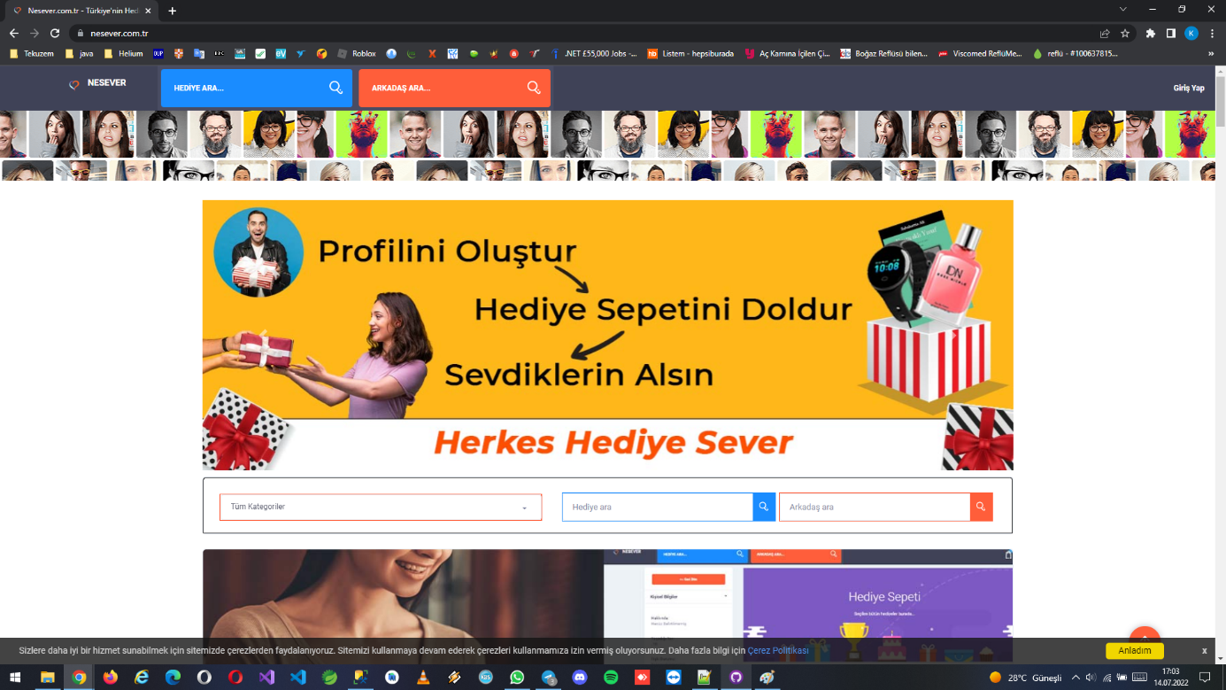

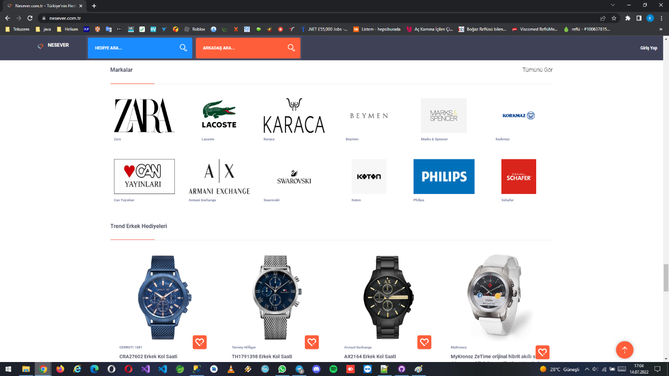

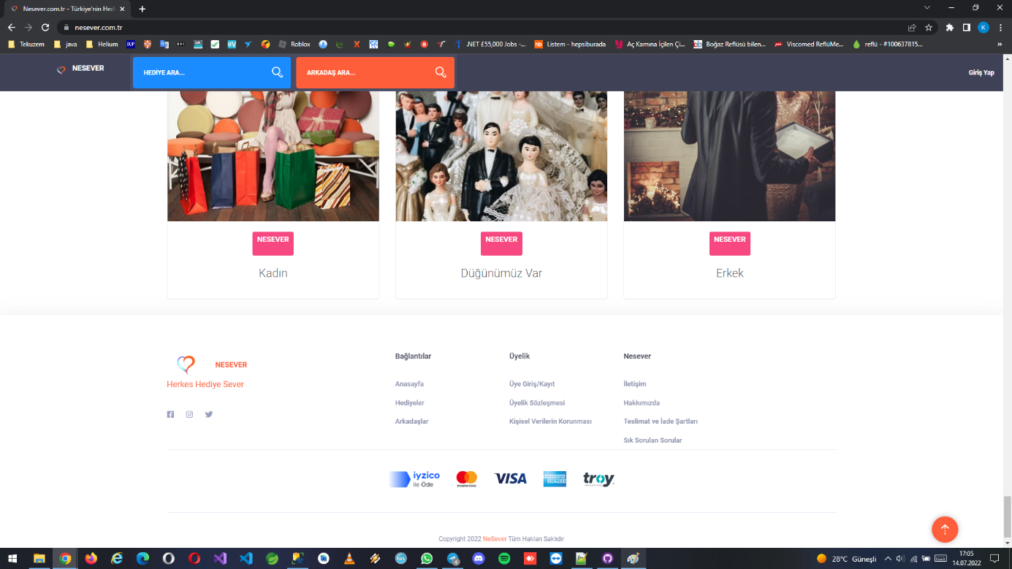

Login and create user pages (can login via facebook or google account)

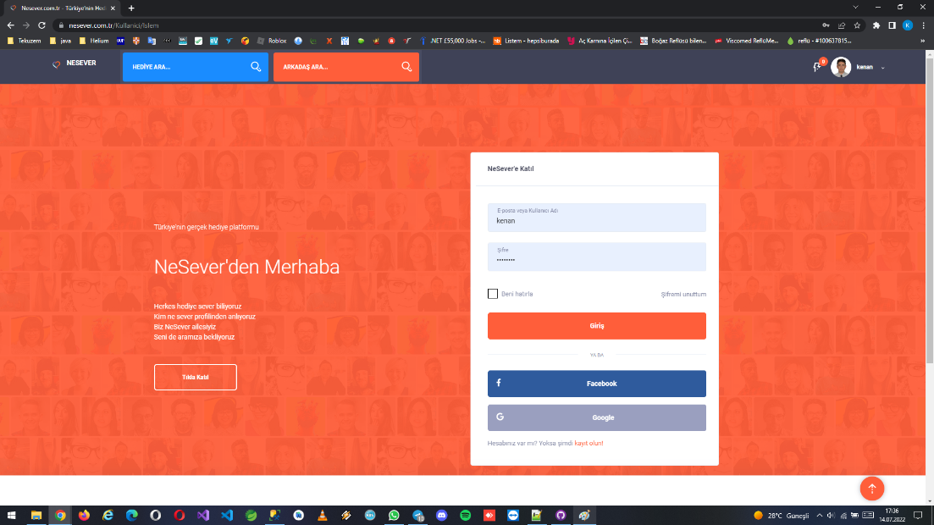

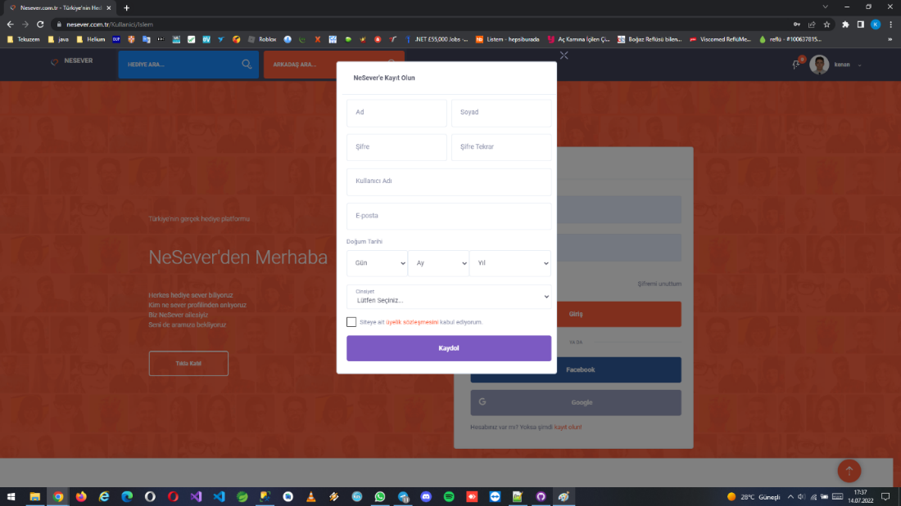

Gifts/Products search and detail pages

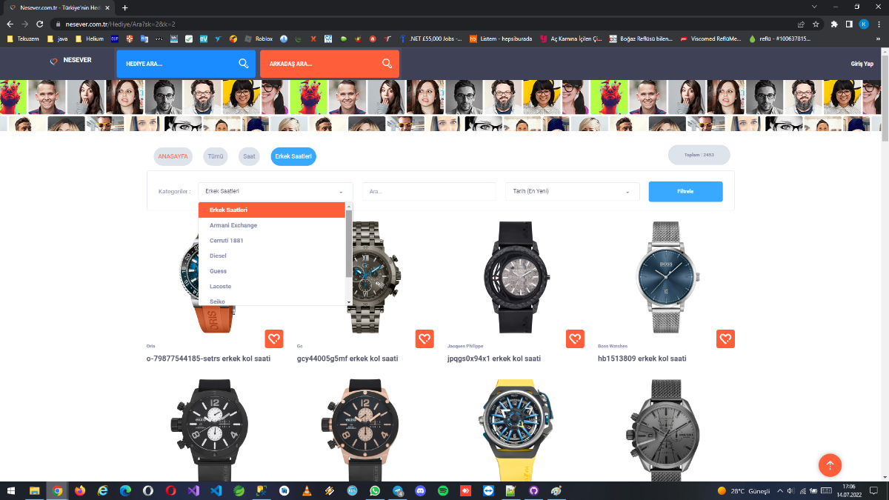

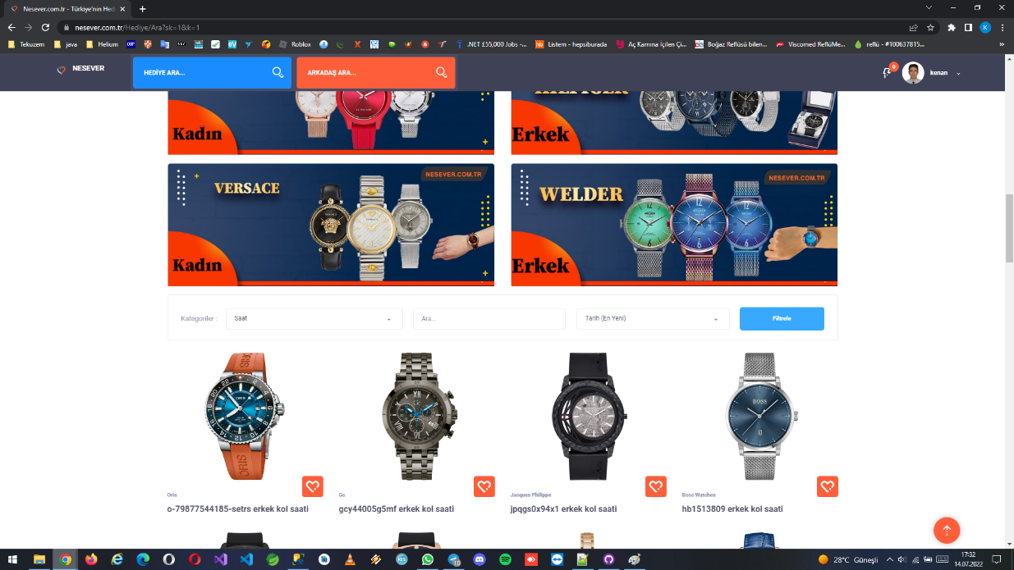

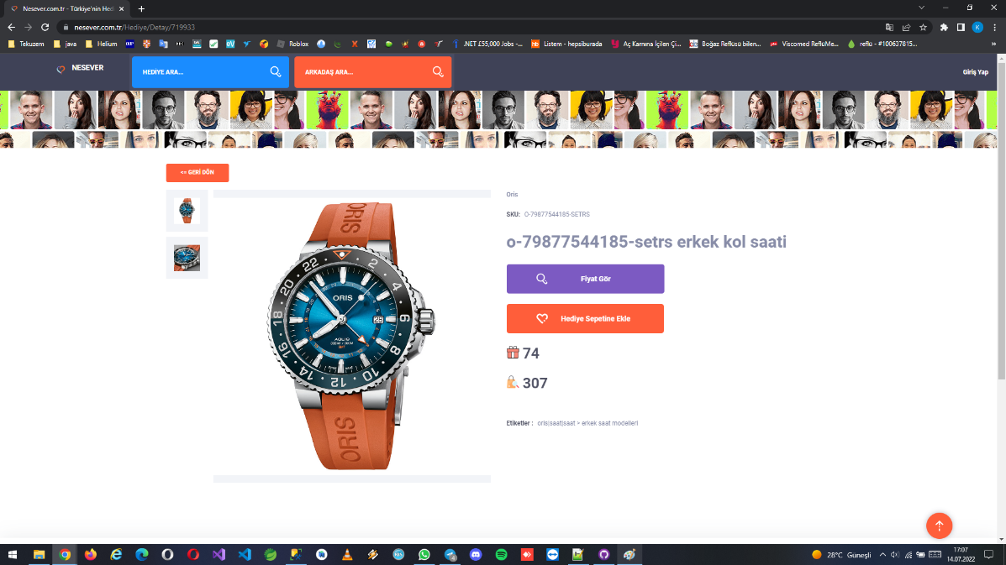

Friend/People/User search page

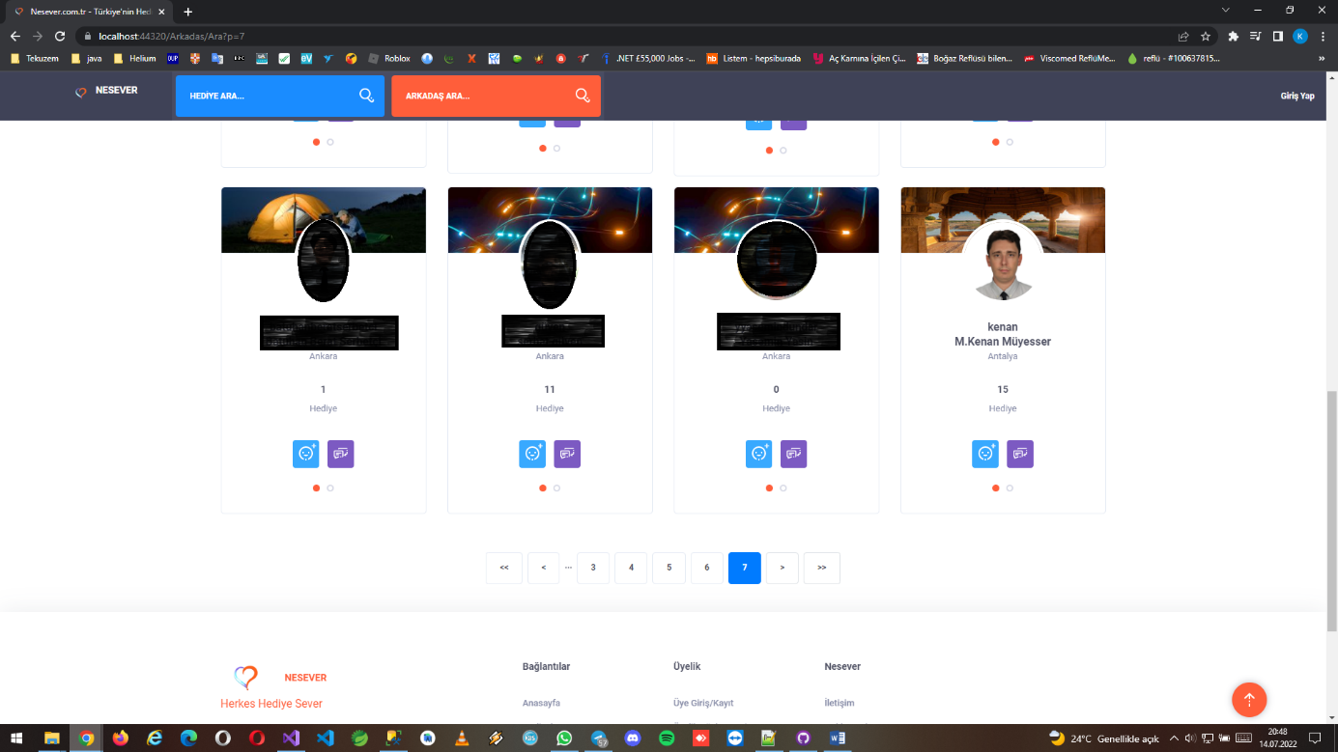

Wall/Personal pages (contains your favorite gifts which was chosen from gift/product lists. And also there are personal information, messages, notifications, friend requests, friend list, photos sections)

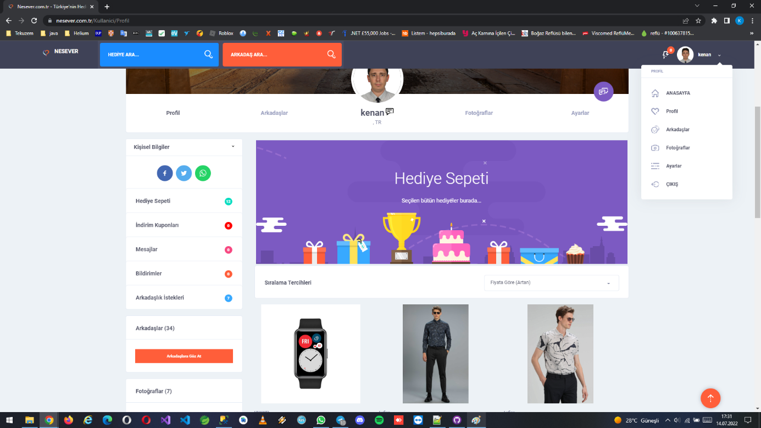

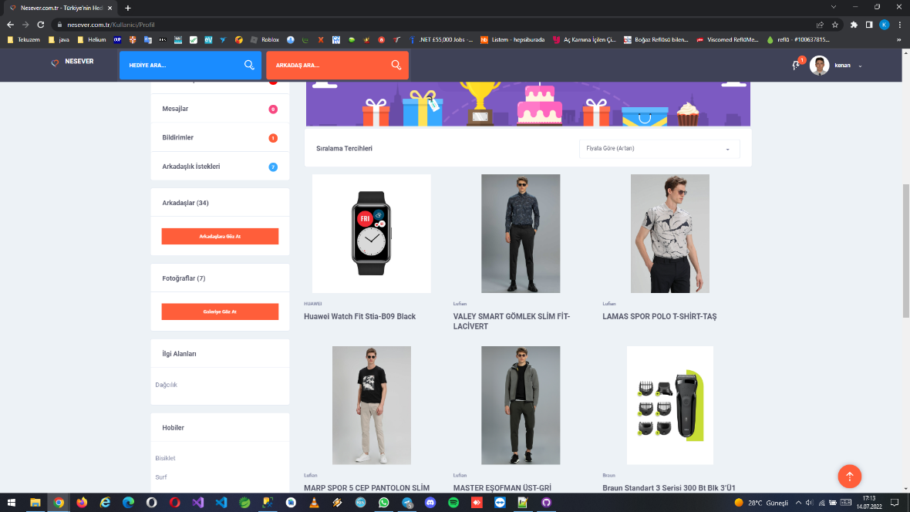

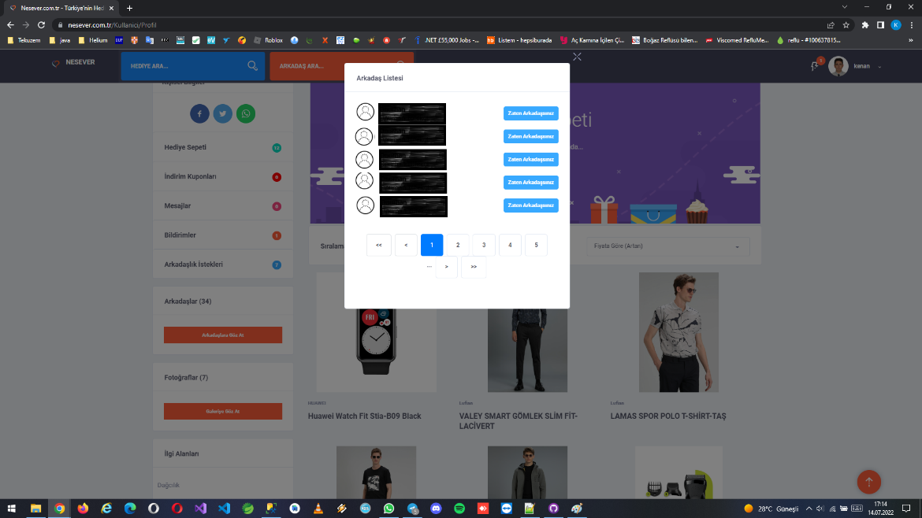

Wall/Personal friend page (this part contains current friend lists, friend requests, your current friends, messages and prevented user list)

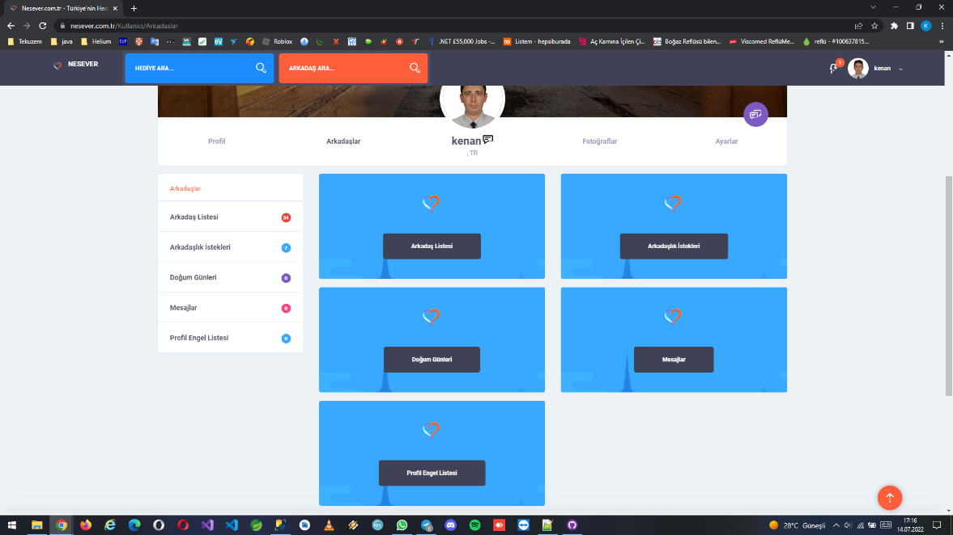

Wall/Personal friend list (you can see friends basic info, send message or remove friends)

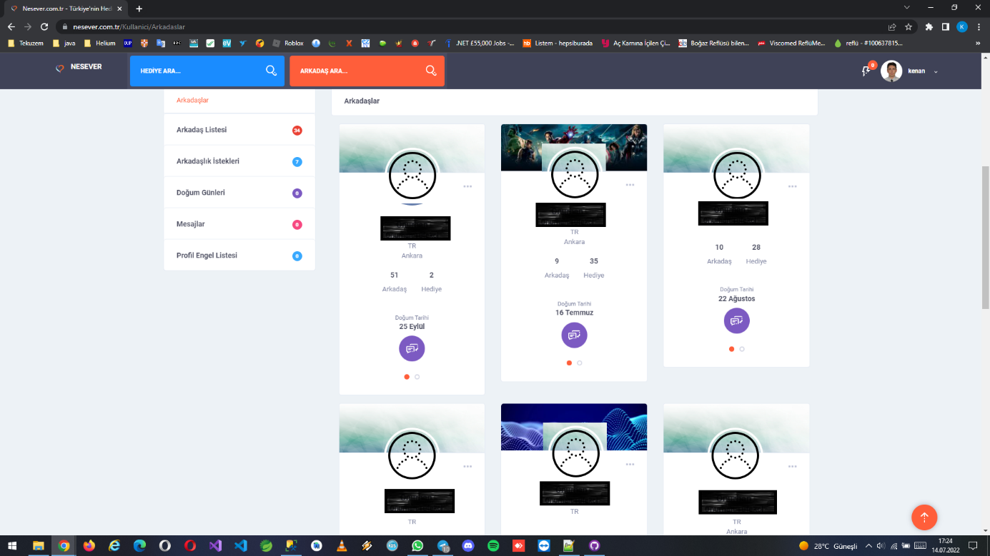

Wall/Personal friend requests (sended friend requests, you can accept or refuse request. If you accept, a notification is sended by system)

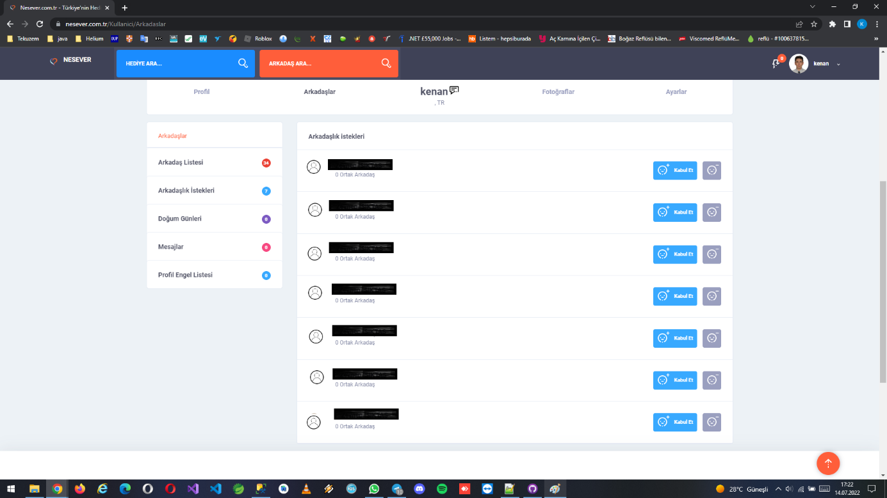

Wall/Personal friends birth date page (current friends birth date list)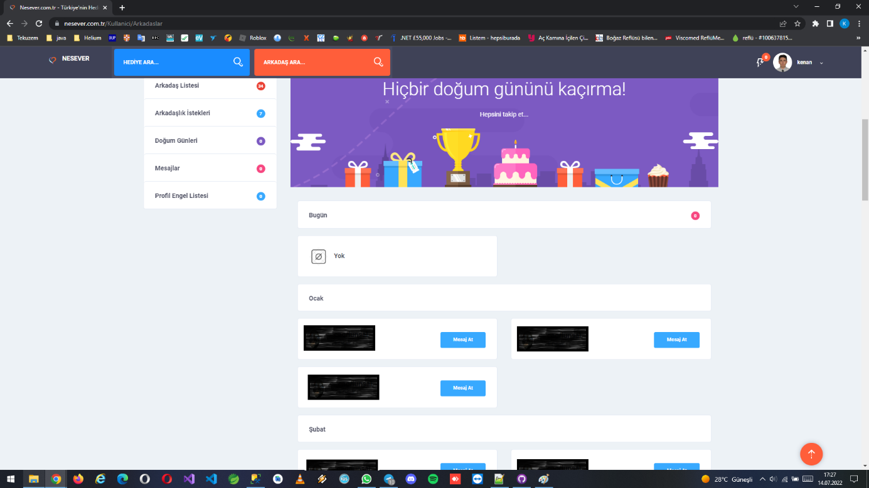

Wall/Personal friends messages page (you can send, read messages)

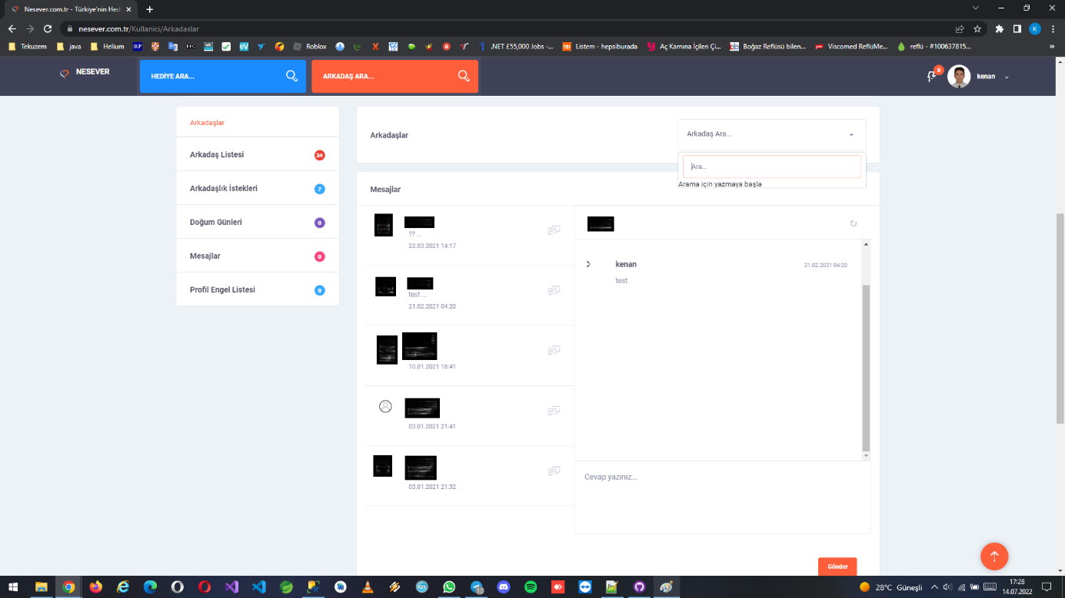

Wall/Personal gallery pages (you can upload profile or gallery photo, set wall picture)

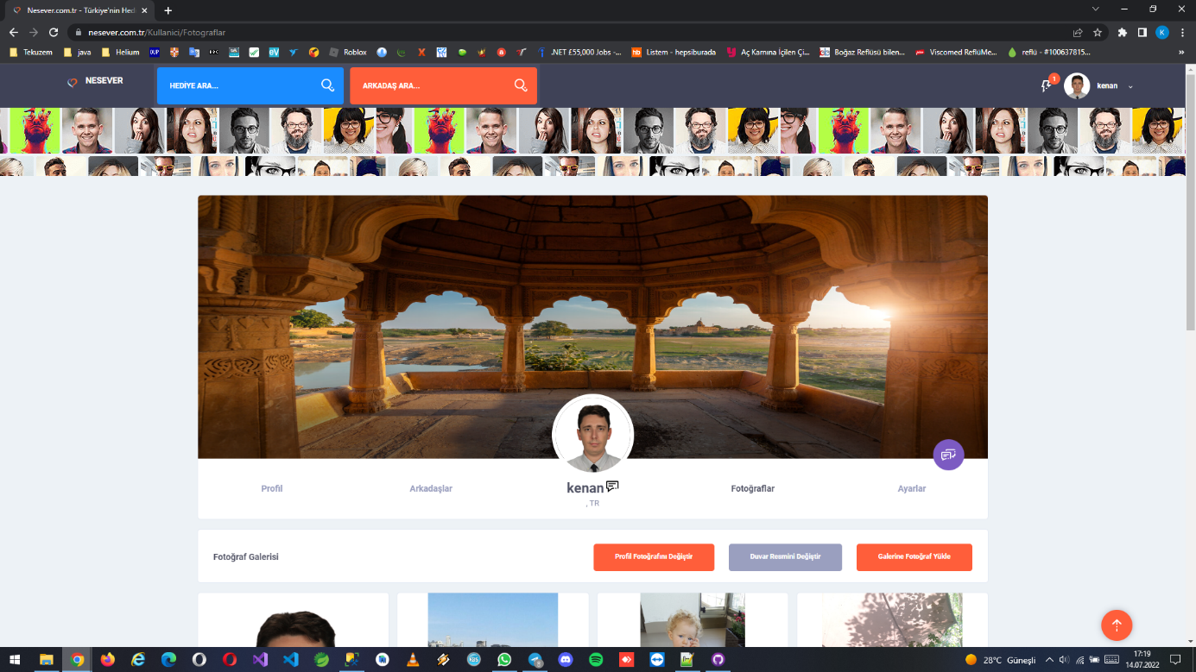

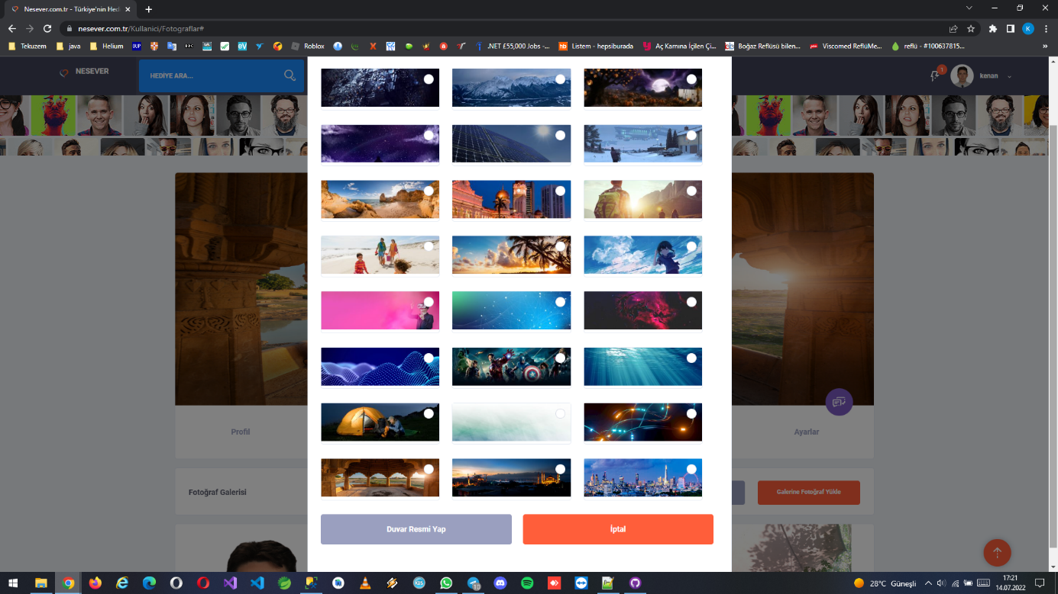

Wall/Personal settings pages (you can update personal information, password, username or change privacy settings)

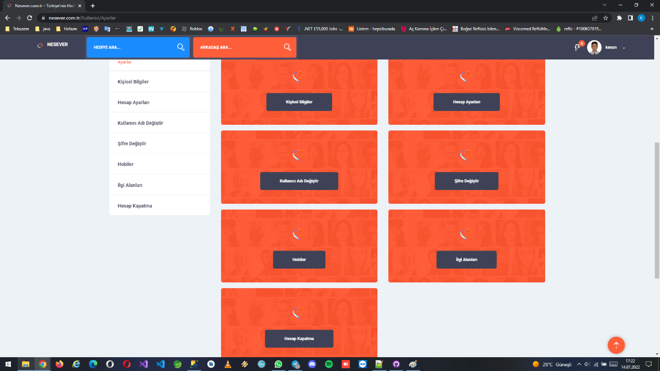

Shopping chart pages (some gifts/products can be bought via credit card or bank transfer)

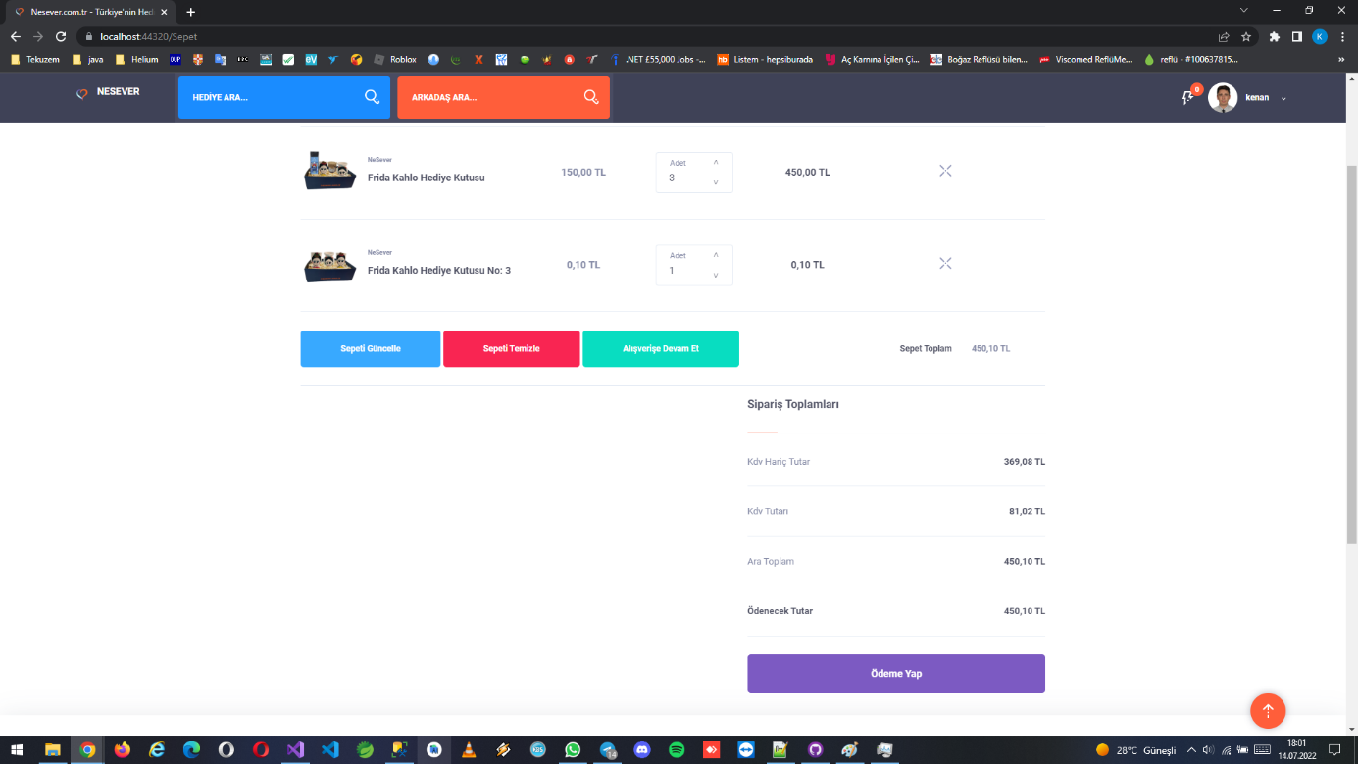

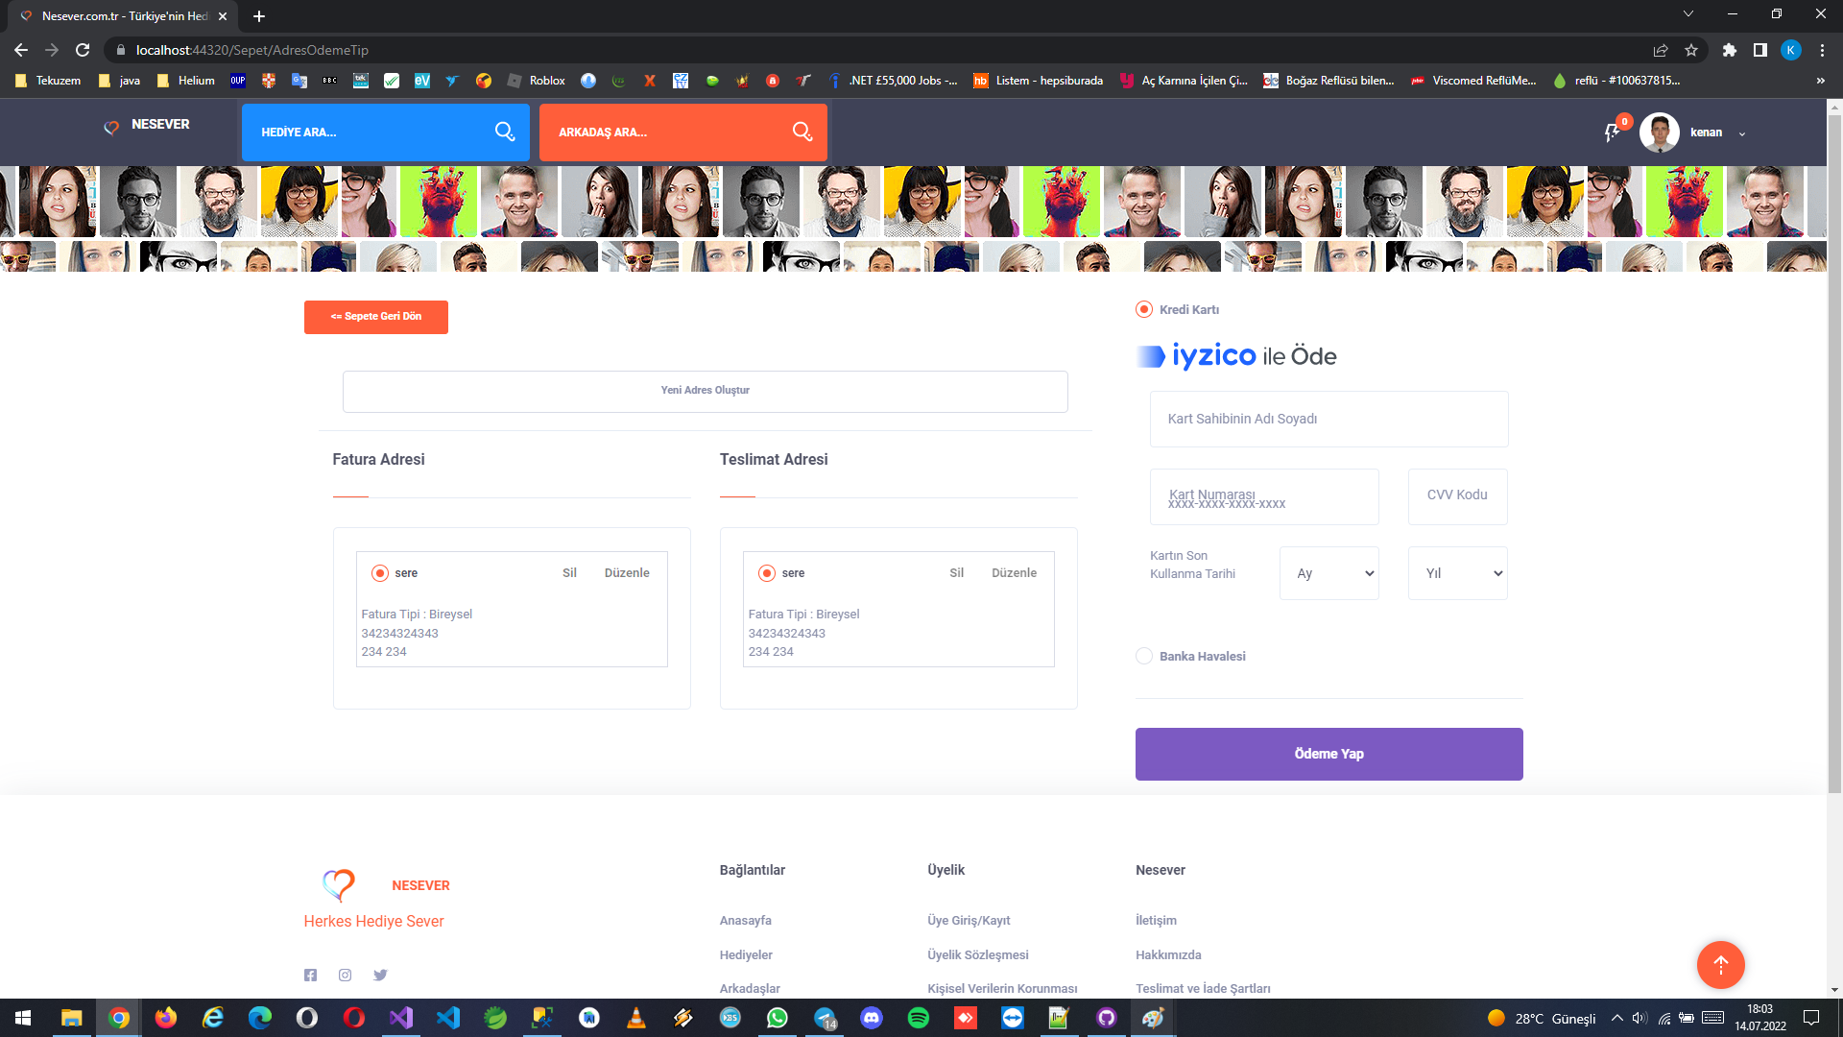

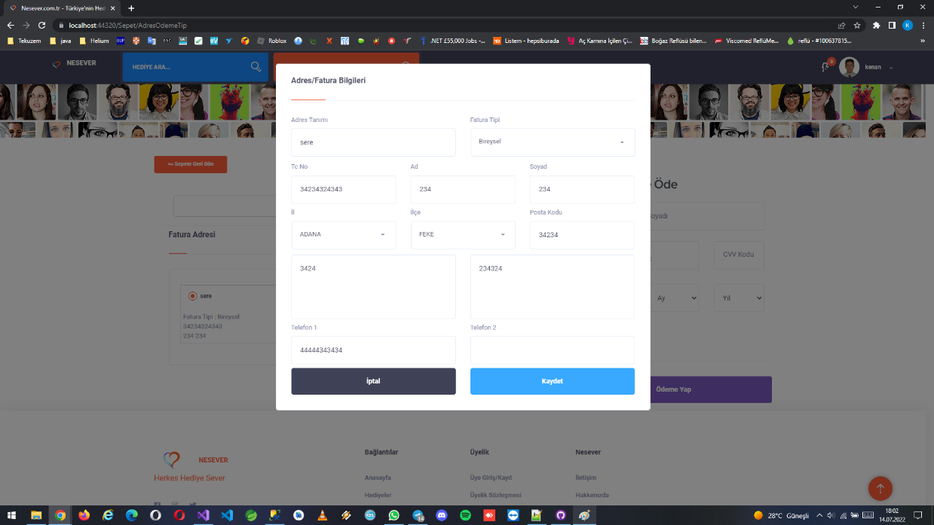

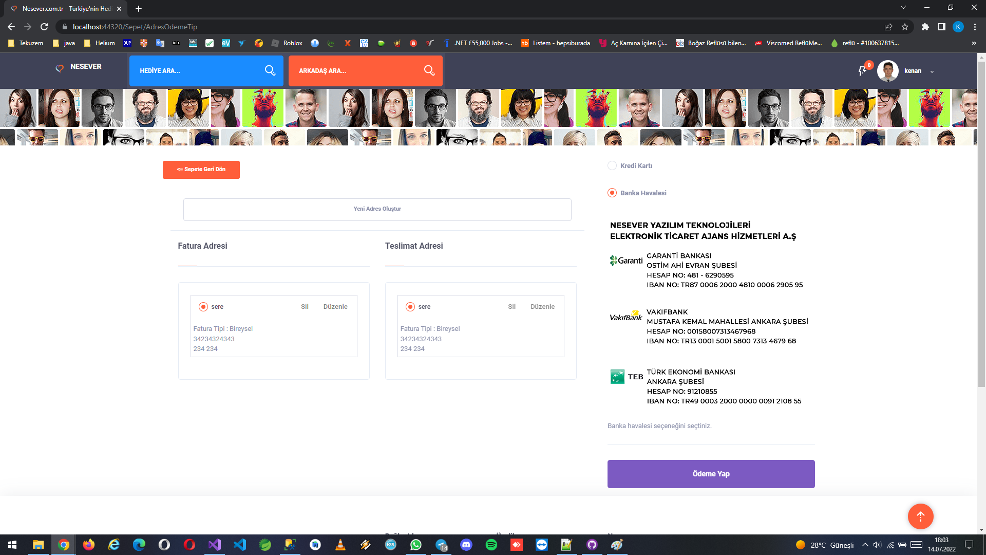

Notifications (it notifies personal messages, friend requests, checked user page, sended by system etc.)

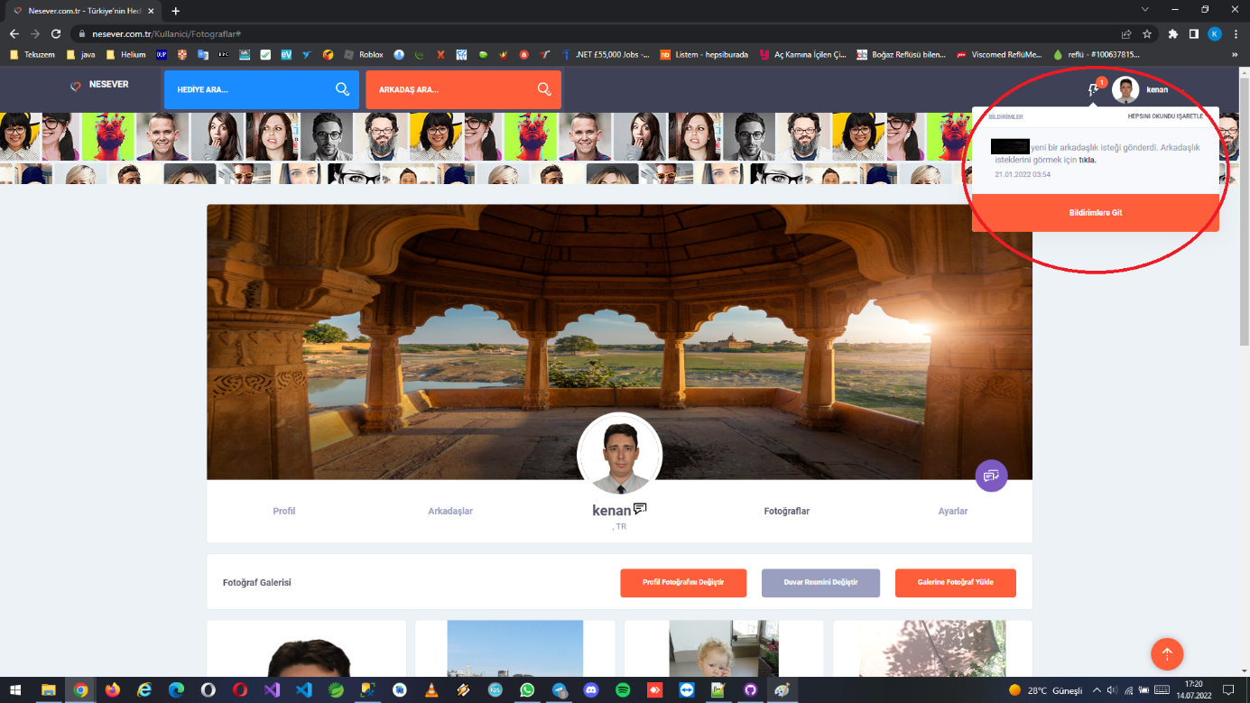

Blog search page

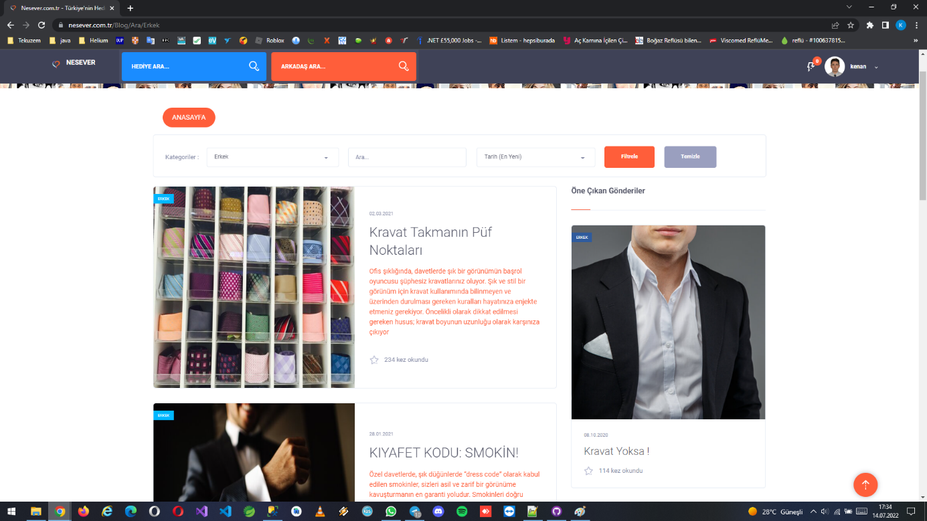

Blog detail page

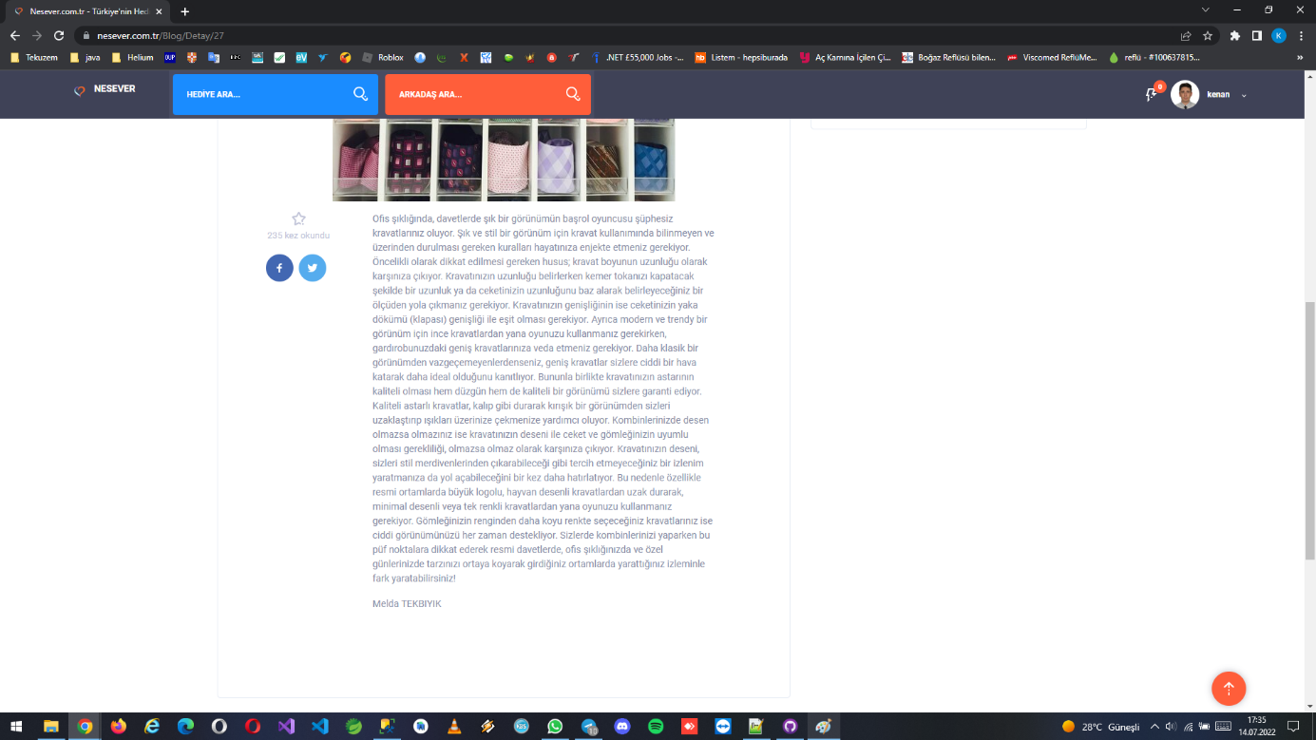

Contact page

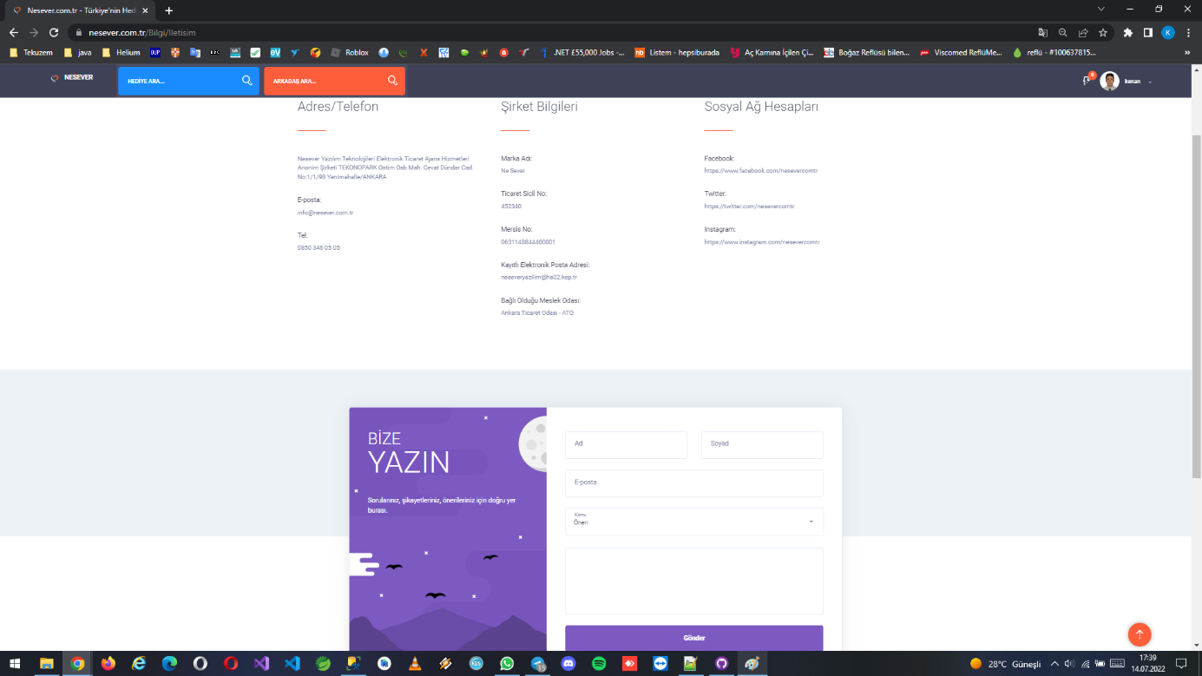

About pages and other info pages

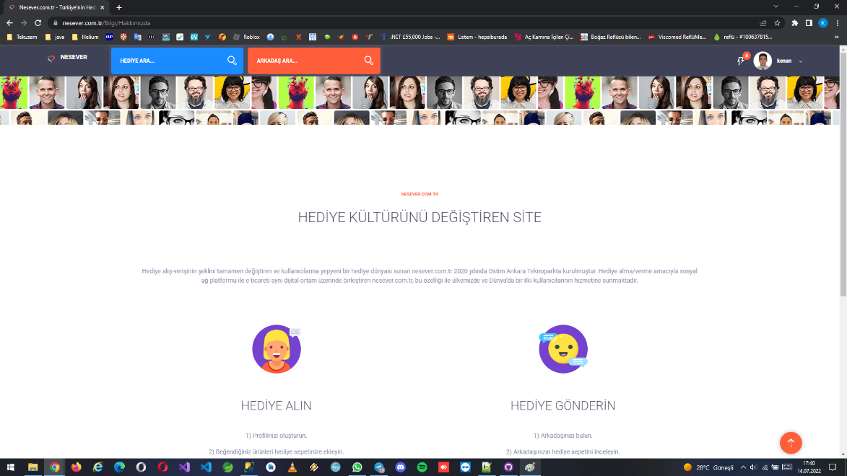

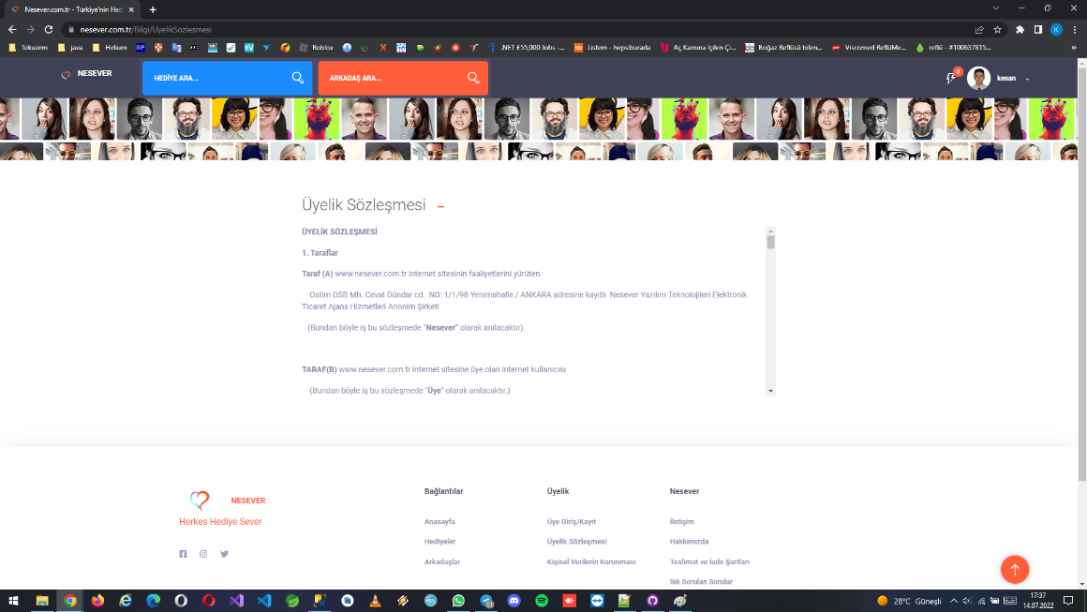

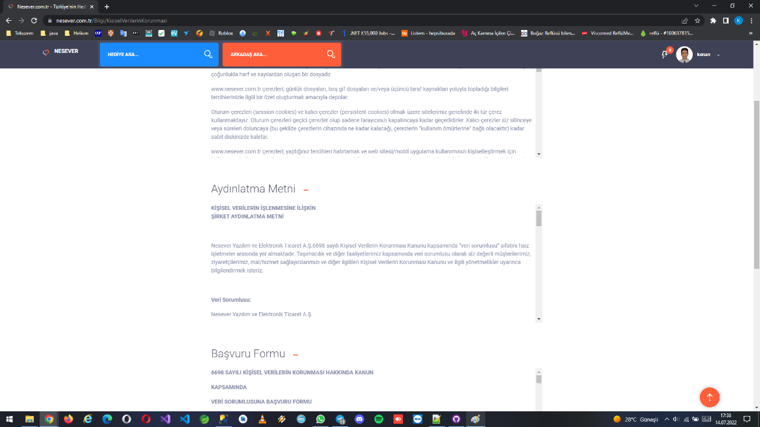

**Admin pages**

Login page (users from outside can’t reach this pages, they only see the missing error page because of ip restriction. İt can set through site settings.)

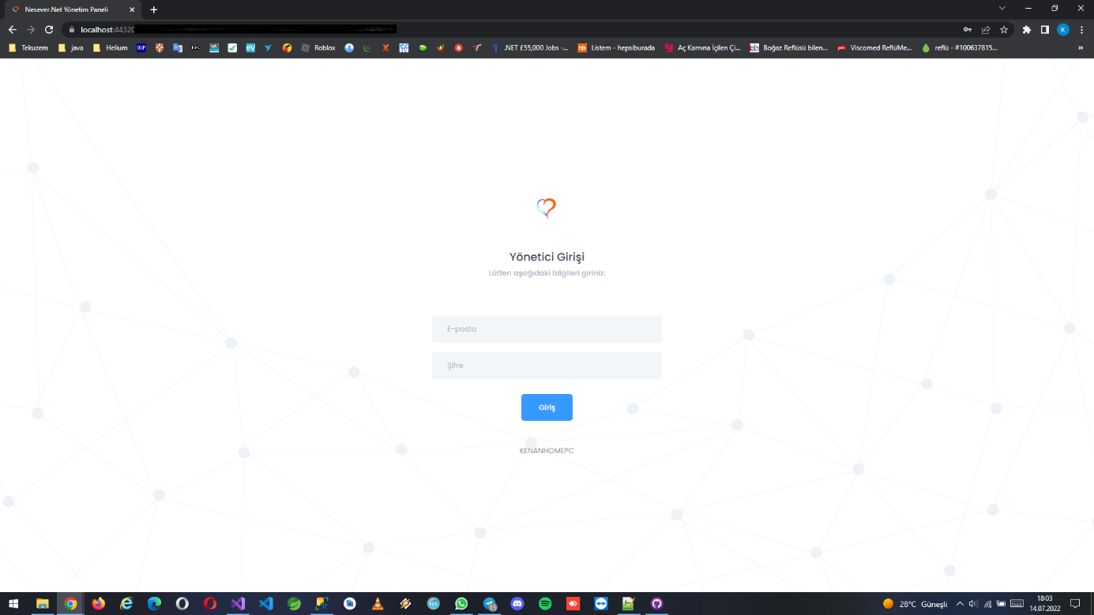

Welcome and statistics page (there are lots of information about website like traffic, number of gifts, number of messages, waiting requests etc.)

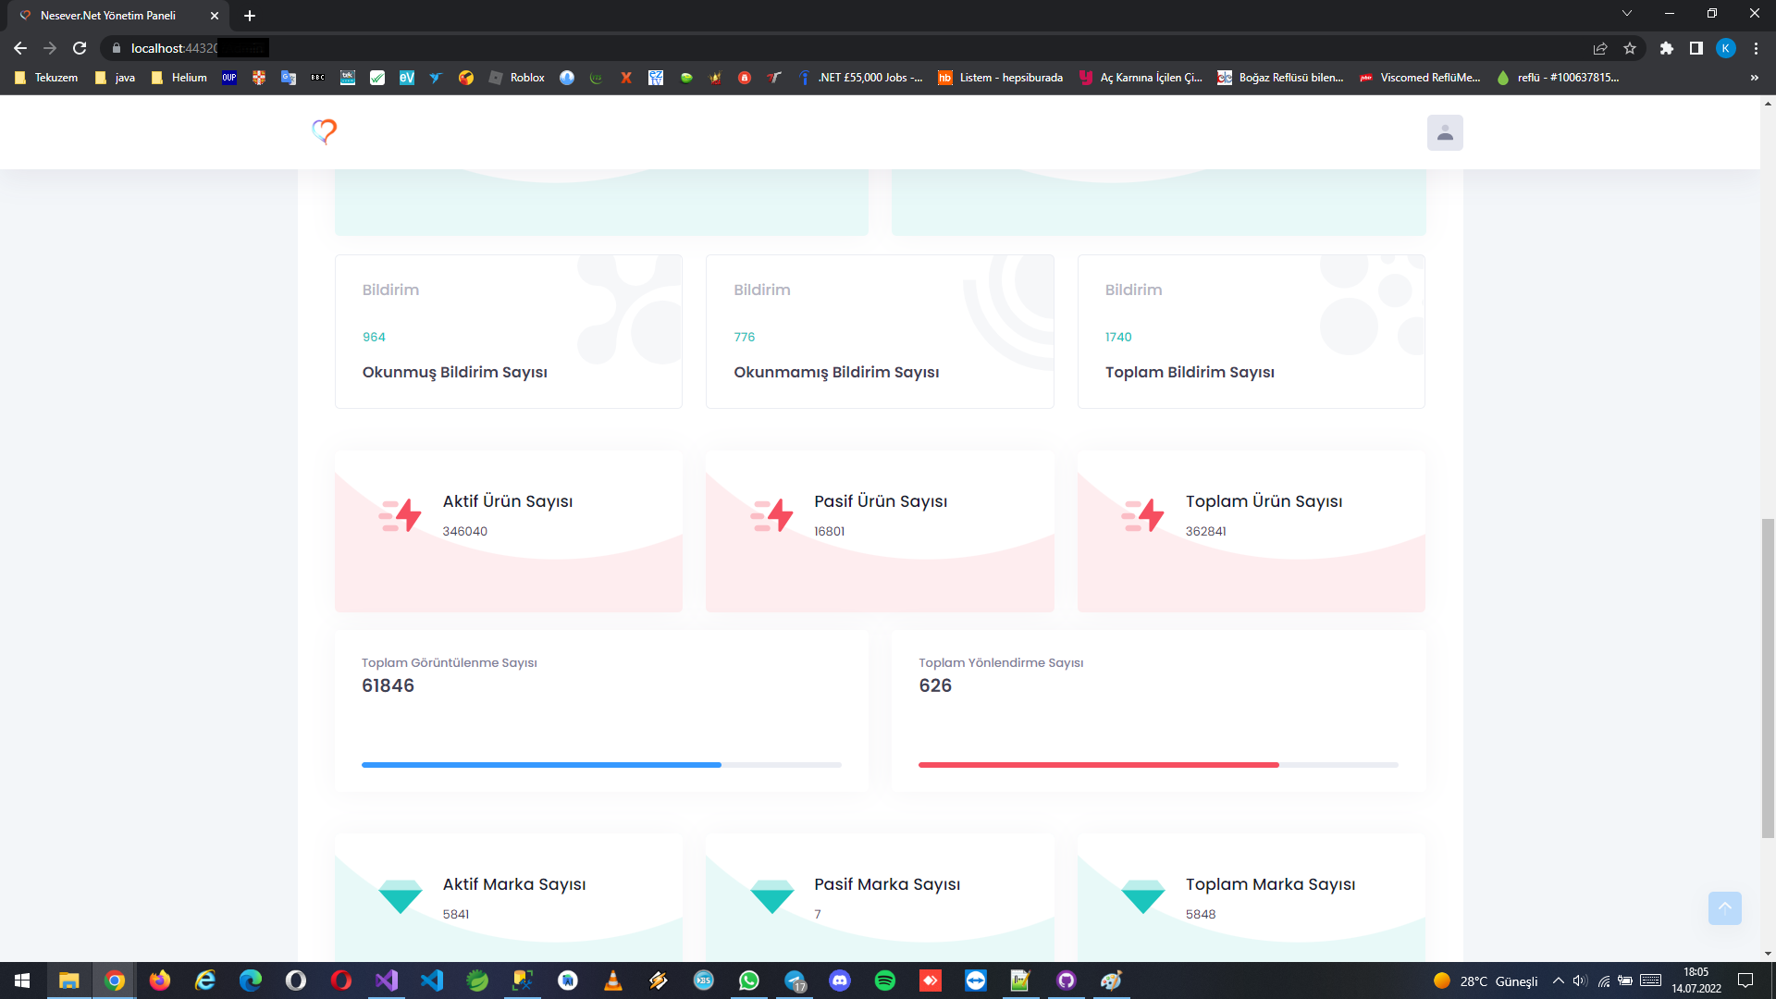

All of website content can configure with this panel. These are blogs, banners, gifts/products (a huge number of products are gotten by robot program which checks producs from websites automaticly), categories and brands (also these are gotten by robot program), user management, sale processes, create notifications, send bulk mails pages.

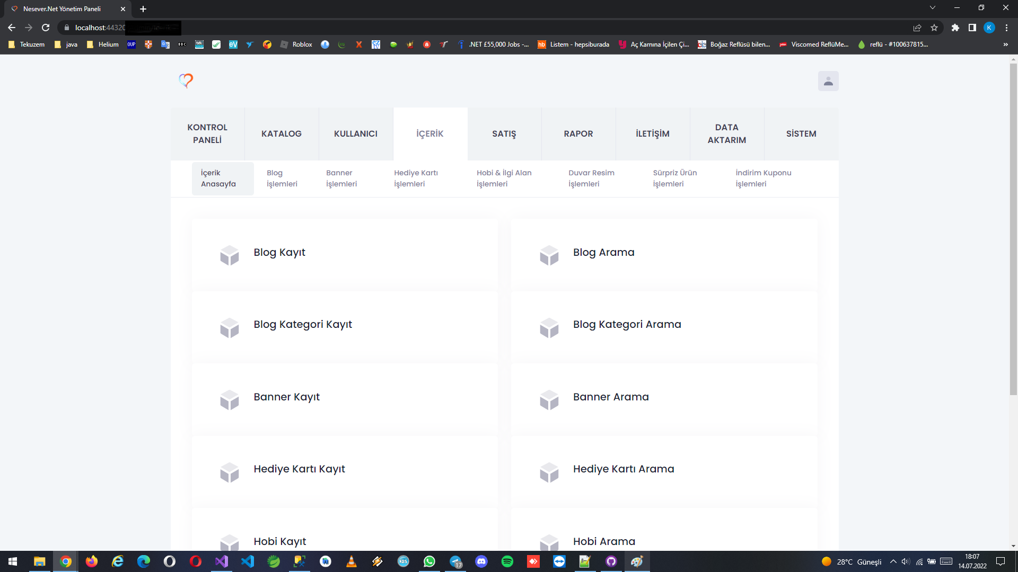

Specific reports and statistics pages

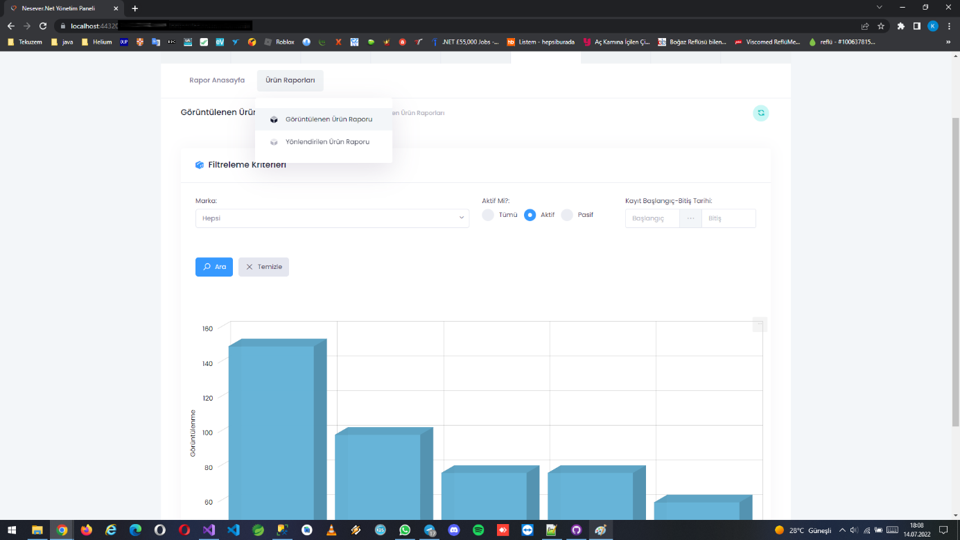

Settings pages (you can manage redis cache, see logs or update programs some features)

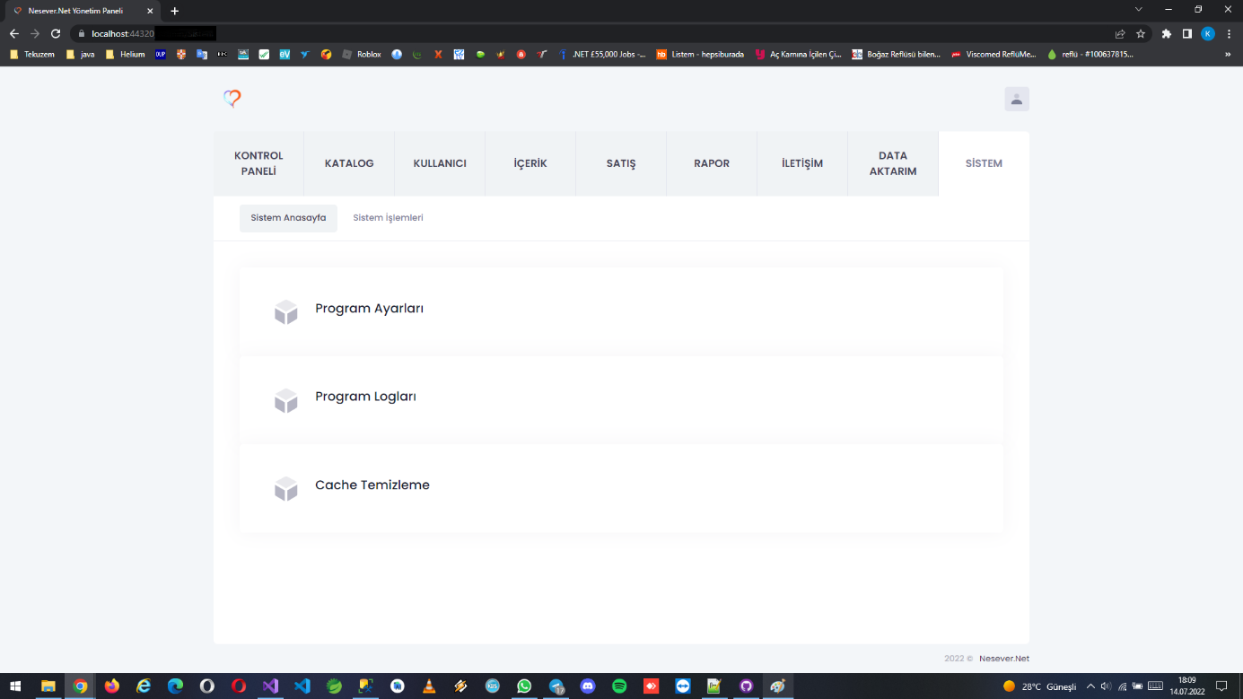

Database Tables

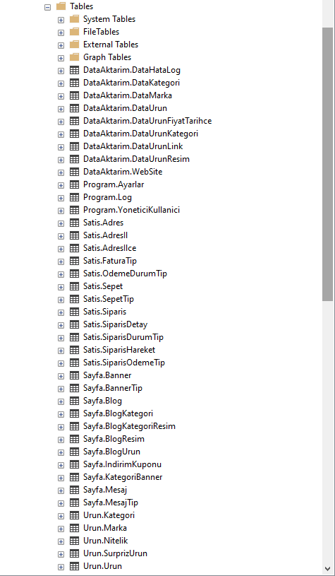

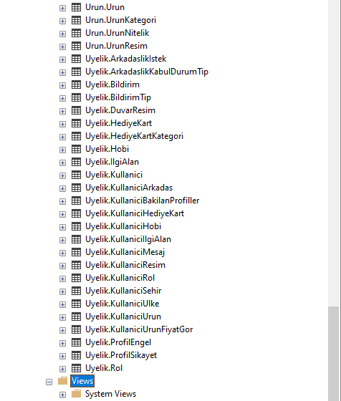

Database Diagram

